**INTRODUCTION TO SCILAB**

**Experiment No. :** **2 Date : 06-01-2019**

**Aim :** Introduction to SCILAB.

**Program :**

*//sine function*

x=0:0.1:10;

subplot(5,1,1);

y=sin(x);

xlabel('x');

ylabel('sin(x)');

plot(x,y);

*//cosine function*

z=cos(x);

subplot(5,1,2);

xlabel('x');

ylabel('cos(x)');

plot(x,z);

*//tangent function*

x=0:0.01:10

k=tan(x);

subplot(5,1,3);

xlabel('x');

ylabel('tan(x)');

plot(x,k);

*//unit step function*

i=1;

x=-20:0.01:20;

for k=-20:0.01:20

if k>=0 then

y(1,i)=1;

else

y(1,i)=0;

end

i=i+1;

end

square(-20,-0.5,20,1.5);

subplot(5,1,4);

xlabel('x');

ylabel('u(x)');

plot(x,y);

*//unit ramp function*

t=-20:0.01:20;

y=t;

subplot(5,1,5);

xlabel('t');

ylabel('r(t)');

plot(t,y);

**Output :**

**COSINE WAVE SINE WAVE**

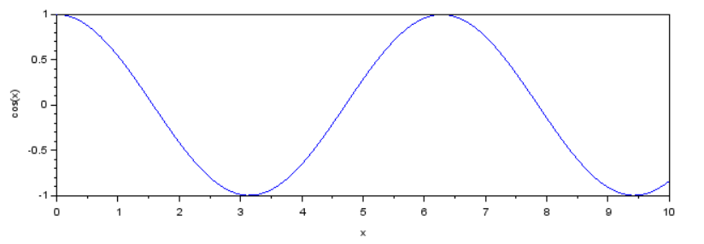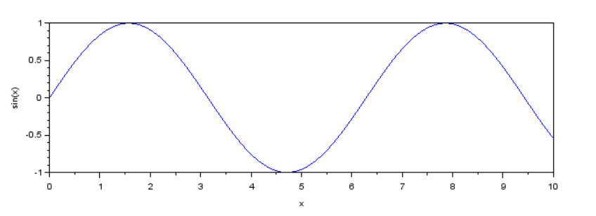

**TAN WAVE UNIT STEP FUNCTION**

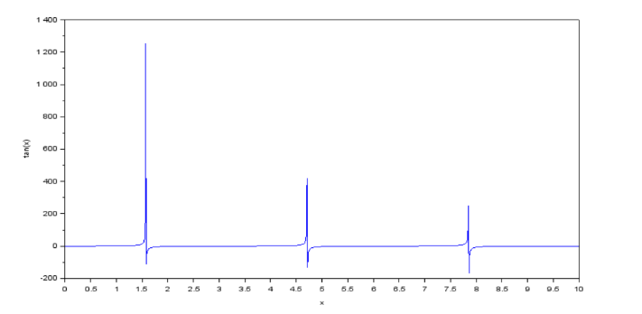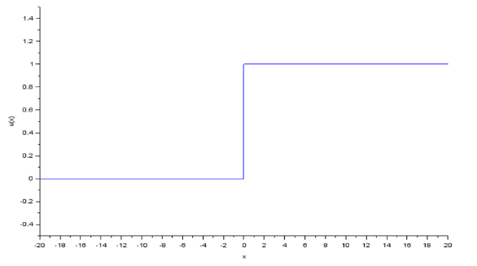

**UNIT RAMP FUNCTION**

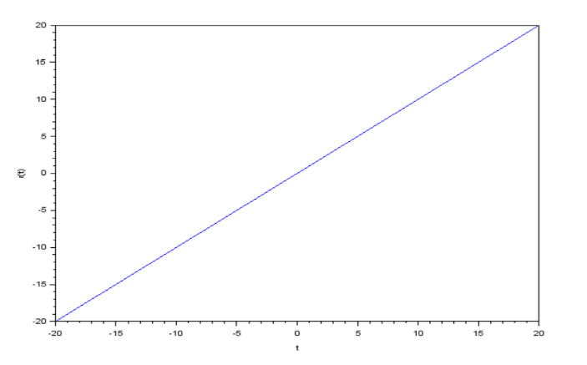

**Conclusion :** Hence using SciLab we can plot various functions.